# Unit 1 – Lesson 5. OOP and Android App Development, Tip Calculator

**Aim:**

1. How do we navigate through the menus and options in Android Studio?
2. What OOP concepts shall we apply in Android app development?
3. What Android development resources are available to us?

**Objectives:** After the lesson, students will be able to:

1. Navigate through Android Studio and get familiar with the layout and menu options
2. Review OOP and understand the relation between OOP and Android app design and development
3. Find and use resources for future Android development

**CLASS PROCEDURE:**

***Do Now:***  Open Android Studio, and open the Simple Calculator App we created yesterday in class. Go to the MainActivity.java, and identify the following components:

1. Class
2. Object
3. Constructor
4. Method
5. Code for instantiation

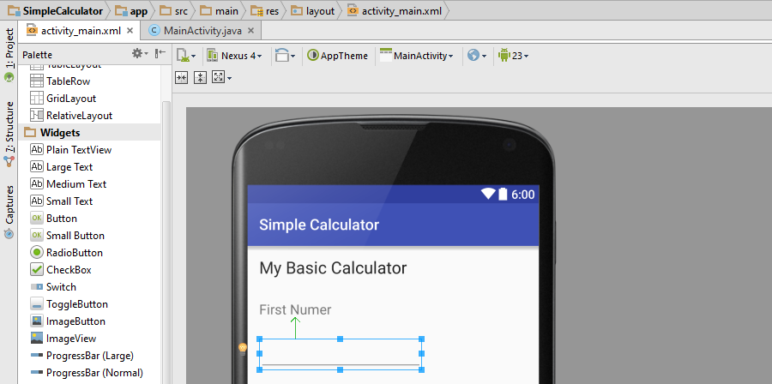

***Class Discussion / Presentation:***

1. What is OOP and what are the two most important features of OOP?
2. In the MainActivity.java, can you identify any inheritance?
3. In the MainActivity.java, can you identify any reused code?
4. In the MainActivity.java, can you identify any encapsulation?
5. Why do developers use OOP for Android app development?

***Pair – sharing Activity #1:***

Copy the Tip Calculator app project into your USB flash drive. Import the app into Android Studio. Open the project, build and run the app.

1. Open the Activity files and the Layout files. Discuss with your partner how this app is designed.
2. What features do you find interesting? Can you “borrow” some of those features in your Binary, Decimal and Hex conversion calculator app?

***Pair –sharing Activity #2:*** Work with your partner on the Binary, Hex and Decimal Conversion App. Use Android Studio to test your project. This is our very first project, and will be counted as 15 project points.